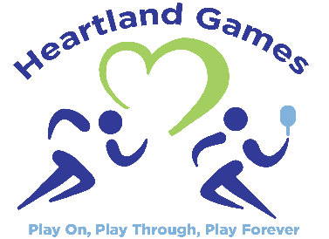
2018 Heartland Games – Event Survey
Thank you for your participation in our 5th Annual Heartland Games! We hope that you have had a wonderful time. We would appreciate your input and suggestions to help with evaluation of this year’s games. And for use in planning our next event in 2019.

Contact Information (Optional): __________________________________________________________

How did you learn about the Heartland Games?
 | Previous Participant |  | Flyer |  | Facebook |  | Poster |  | Email |  | Word of Mouth

Other _____________________

How did you register for the Heartland Games?
 | Online |  | By Mail |  | In Person |  | Day of Event |  | Other

Venue:
 | Pickleball (Family Life Center) |  | Track & Field (Friends University)

How would you rate your experience at the Heartland Games?
Registration Excellent Good Needs Work N/A
Check-In Excellent Good Needs Work N/A
Lunch Excellent Good Needs Work N/A
Snacks Excellent Good Needs Work N/A
Flow of Events at Your Location Excellent Good Needs Work N/A
Location/Venue Excellent Good Needs Work N/A
Closing/Awards Excellent Good Needs Work N/A

Do you have any suggestions for additional events for the future? _____________________________

_____________________________________________________________________________________

Do you have any additional comments or suggestions on improving the Heartland Games? _________

_____________________________________________________________________________________

